Workflow manager configuraiton;

Follow the given video guide

<https://docs.microsoft.com/en-us/sharepoint/governance/video-series-install-and-configure-workflow-in-sharepoint-server-2013>

Click on the link below to download workflow manager 1.0:

<https://docs.microsoft.com/en-us/previous-versions/dotnet/workflow-manager/jj193448(v=azure.10)>

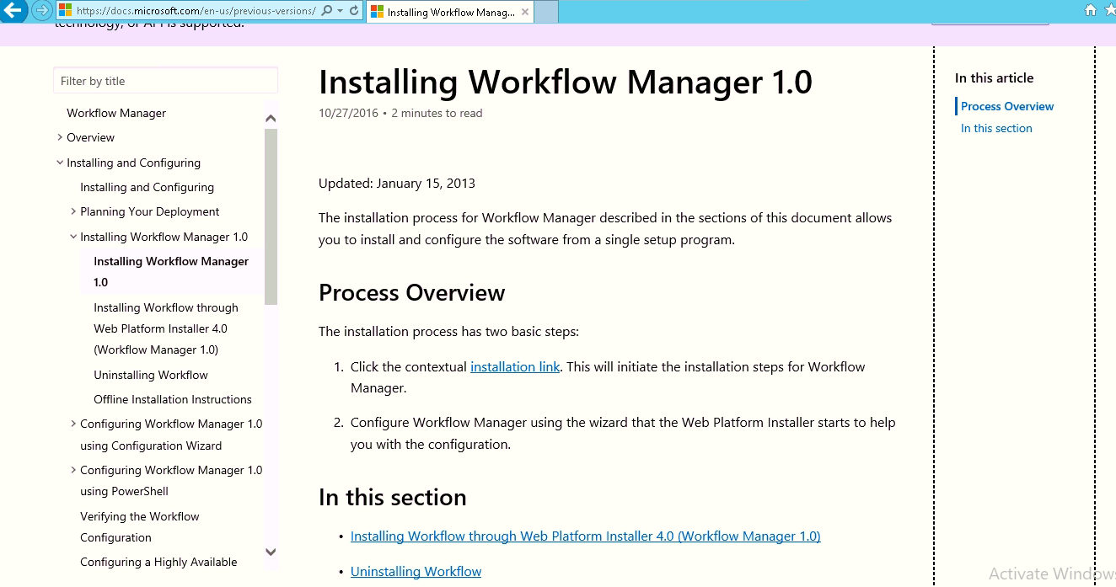

on this page, click on installation link.

It will download web platform installer. Click on run so it will download and run the setup. After download, the wizard will start. Keep in mind, installing workflow manager 1.0 not upgrading. After installing workflow manager 1.0, install CU 5. After all is done. You need to run configuration wizard.

Follow the steps added in below screenshots

* Run installer and install following manager
* Once complete close the configuration wizard and then finish the setup

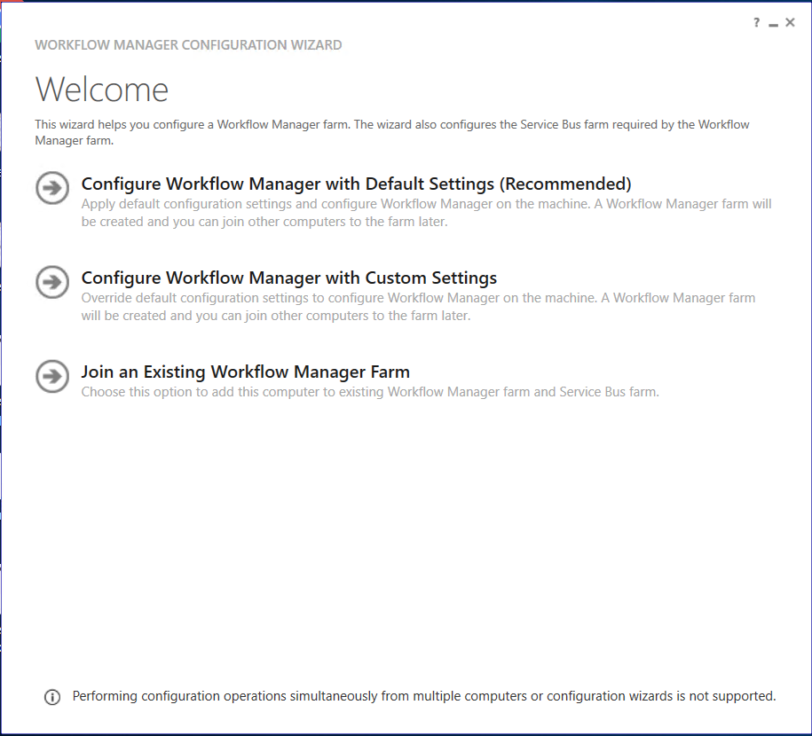

* Run Microsoft installer again and install following cu



* Open workflow manager configuration from Start menu and select



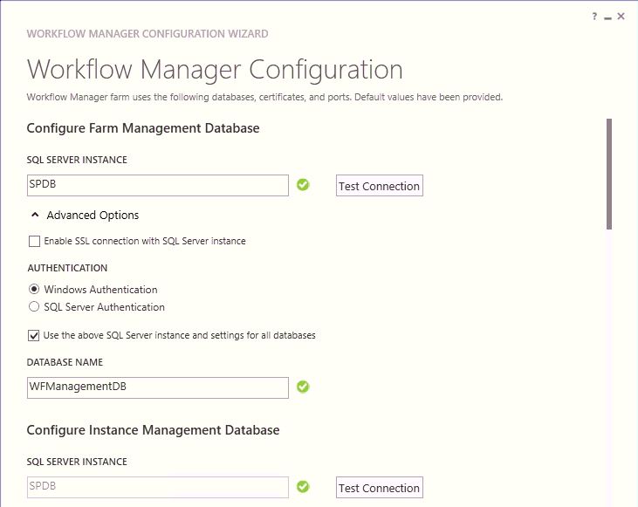

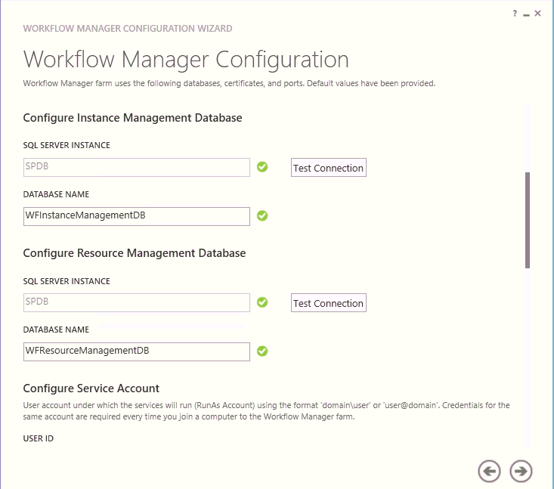

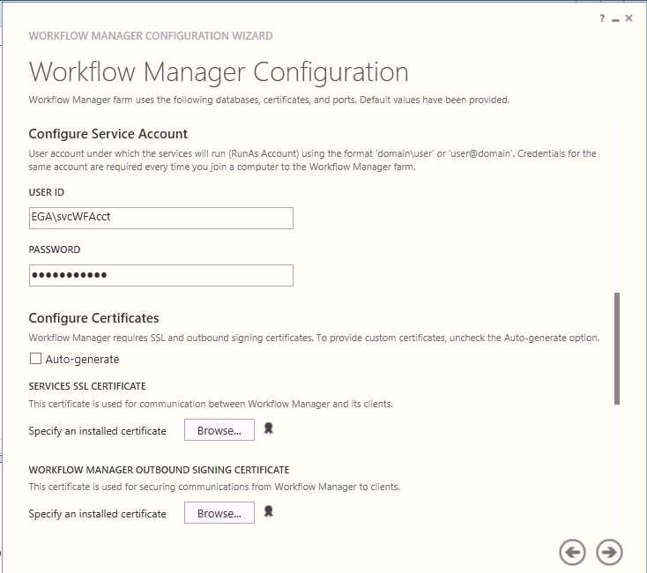

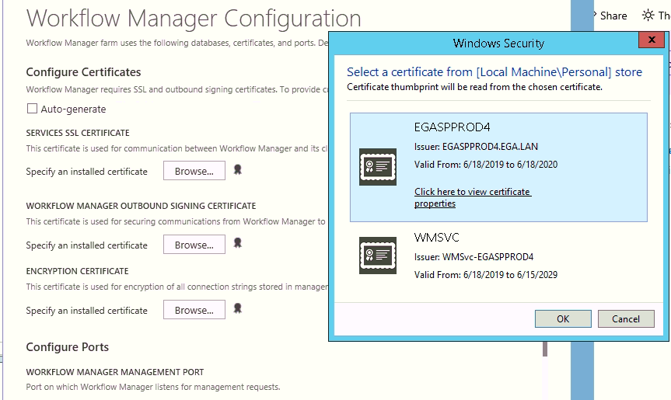

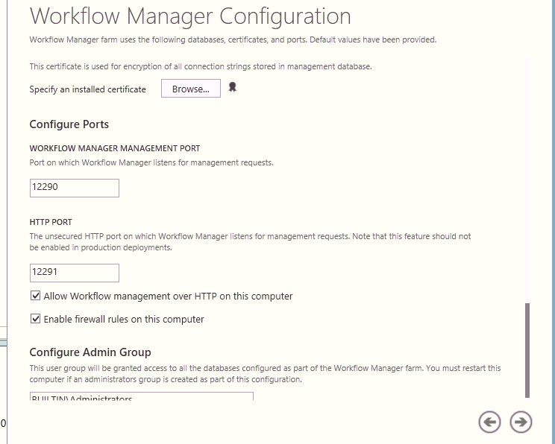

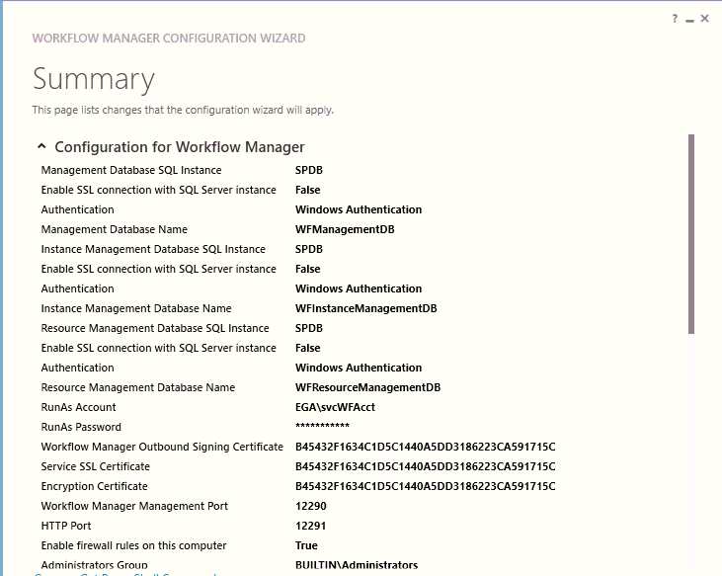

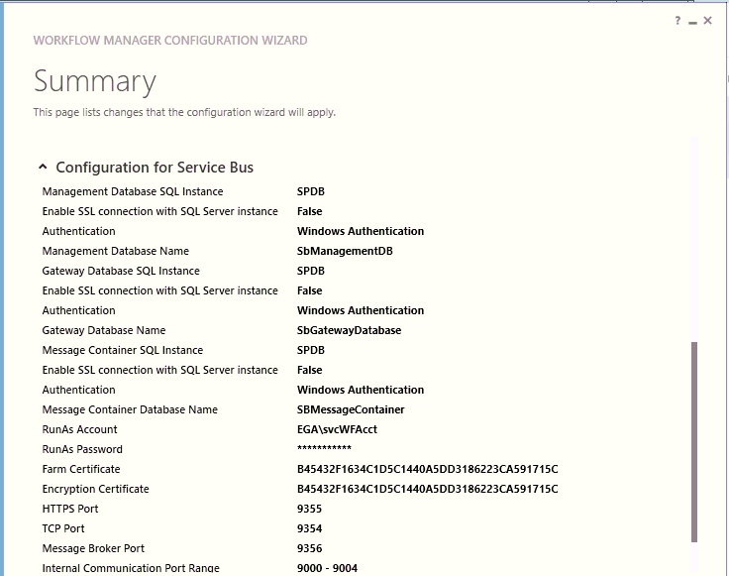

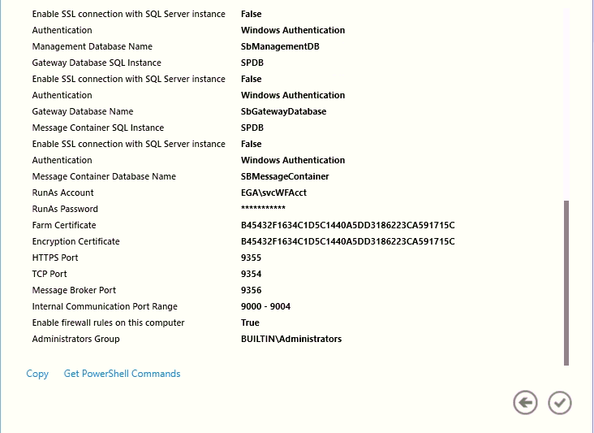

Once configuration wizard is completed. Add the generated certificate in SharePoint server certificate under **Trusted Root Authority, Personal folder.**

Also, add generated Certificate to trust management in Central Administration.

1. Let us go to the Central Administration

[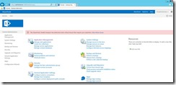](https://www.sharepointpals.com/wp-content/uploads/be/clip_image024_3.jpg)

2. Go to the Security.

[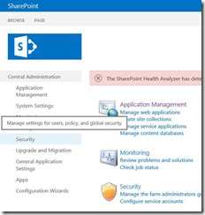](https://www.sharepointpals.com/wp-content/uploads/be/clip_image026_2.jpg)

3. Click on the Manage Trust.

[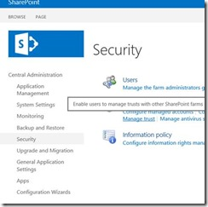](https://www.sharepointpals.com/wp-content/uploads/be/clip_image028_2.jpg)

4. You will be able to see the existing trusted certificates.

5. Click on new.

[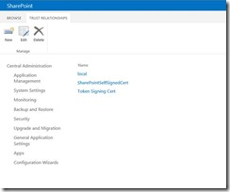](https://www.sharepointpals.com/wp-content/uploads/be/clip_image030_2.jpg)

6. On the Popup, select the new certificate added in sharepoint server.

[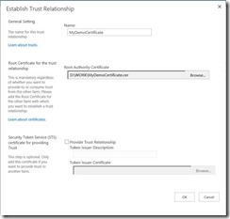](https://www.sharepointpals.com/wp-content/uploads/be/clip_image032_1.jpg)

7. We will be able to see the certificate on the list.

[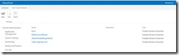](https://www.sharepointpals.com/wp-content/uploads/be/clip_image034_1.jpg)